# Q1: CODE:

Include Irvine32.inc

.data

msg BYTE "hammad",0

.code main PROC

mov esi, 0

mov edi, 0

mov ecx, SIZEOF msg mov eax, OFFSET msg mov esi, eax

add eax, ecx mov edi, eax dec edi

dec edi shr ecx,1

L1:

mov al, [esi] mov bl, [edi] mov [esi], bl mov [edi], al inc esi

dec edi loop l1

; display the string

mov edx,OFFSET msg call writeString call crlf

exit

main ENDP END main

# MUHAMMAD HASSAM KHAN

# SID: 11141

**LAB 7**

**SCREENSHOT:**

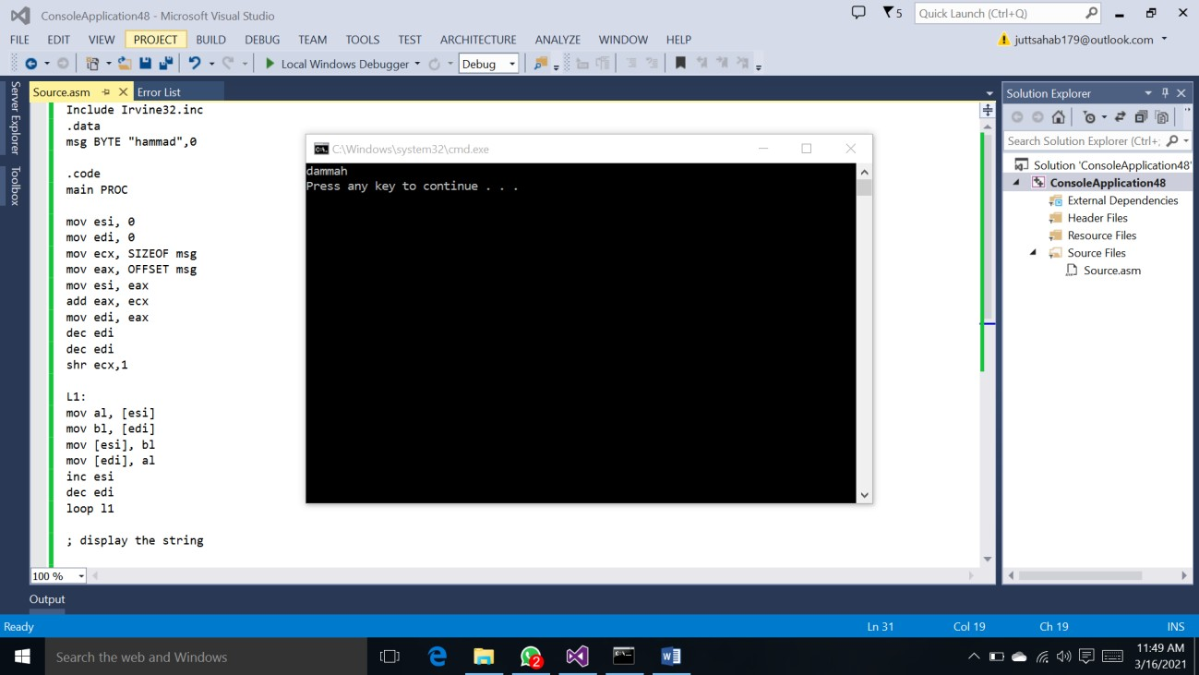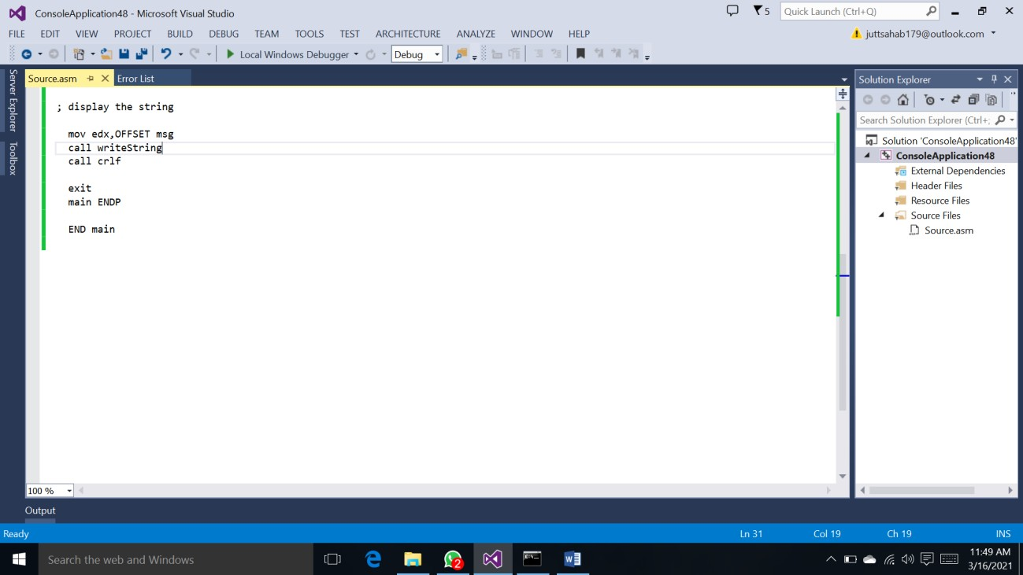

**Q2:**

**CODE:**

Include Irvine32.inc

.data

val1 SDWORD 8

val2 SDWORD 15

val3 SDWORD 20

num SDWORD 7

.code main PROC

mov eax,val2 neg eax

add eax,num sub eax,val3 add eax,val1

call writeint call crlf

exit

main ENDP END main

# SCREENSHOT:

